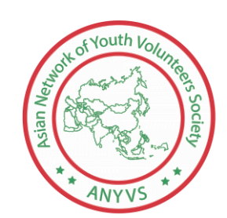
MEMBERSHIP FORM
Asian Network of Youth Volunteers Society
Photo
Address: 69/A, Dhanmondi 6/A, Dhanmondi-1209, Bangladesh
Contact: +8801841313658; E-mail: info@anyv.org
Facebook: www.facebook.com/anyvsocieties
Website: www.anyv.org

PERSONAL INFORMATION
Name: | Nationality:  Country:
Father’s Name: | Mother’s Name:
Date of Birth: | NID/SSID:
Gender: Female Male Others: | Blood Group:
Contact No. (With country code): | E-mail:
Facebook Id (if any): | Occupation:
Present address:

Permanent address:

List of activities you have involved with: (Attach extra page if necessary)

1.

2.

3.

4.

5.

Highest Academic Background:

Achievement/Award:
Why do you want to join ANYVS? : (Attach extra page if necessary)

How you can contribute to ANYVS? : (Attach extra page if necessary)

How you can establish secular Nation? :

Who is your idol in nation Building and Why? : (Attach extra page if necessary)

Details of Two Referees:
The Society reserves the right to contact referees about any statement in the application
 | Referee 1 | Referee 2
Name:
Job title and employer:
Address:
E-mail and Phone:
Facebook/ Website
Numbers of years known to you:
APPLICANT’S DECLARATION
I certify that the information contained in this form and any accompanying documentation is correct. I will be bound to obey by the Society’s By-Laws and Codes of Conducts and I shall maintain the objective of the ANYVS. I accept the Society reserves the right to expel me if any of the information in this form and any accompanying documentation are found to be falsified.

Applicant’s Signature:

Print name: | Date:

For office use only
Form no. : | Date of Received:
Applicant’s name:
Type of membership suggested | Remarks
- Volunteer Member
- Associate Member
- General Member
- Life Member
- Provisional
- Not accepted

Authorized Signature and Seal: | Date:

